Cybersecurity & Ethical Hacking Internship
– ApexPlanet Software Pvt. Ltd. Report

Task Number: 1 – Lab Setup
Name: Jai Rane
Intern ID: APSPL2641663
Date: 15-07-2026

- Objective: To build strong fundamentals in cybersecurity, networking, cryptography, and set up a professional hacking lab.
- Tools & Environment
Tool / Environment | Version / Details | Notes
VirtualBox | 7.1.8r168469 | Used to run the virtual machines
Kali Linux | 2025.2 (VirtualBox Pre-Built Image, amd64) | Main OS for penetration testing & Linux practice
Nmap | 7.95 | To be used for network scanning & vulnerability assessment in future tasks
Metasploitable | V6.4.64-dev | Will be used in later tasks for exploitation practice
Wireshark | 4.4.6 | Planned for future tasks like packet analysis
Host System | Windows 10/11 (64-bit) | Physical machine running VirtualBox
Host Hardware | Intel i3, 8 GB RAM, 512 GB SSD | System specifications of the laptop
VM Allocation | 4 GB RAM, 2 CPU cores | Resources assigned to Kali VM
4. Procedure
Step 1: Downloading VirtualBox and Kali Linux Pre-Built Image
Downloaded VirtualBox 7.x from the official Oracle website.
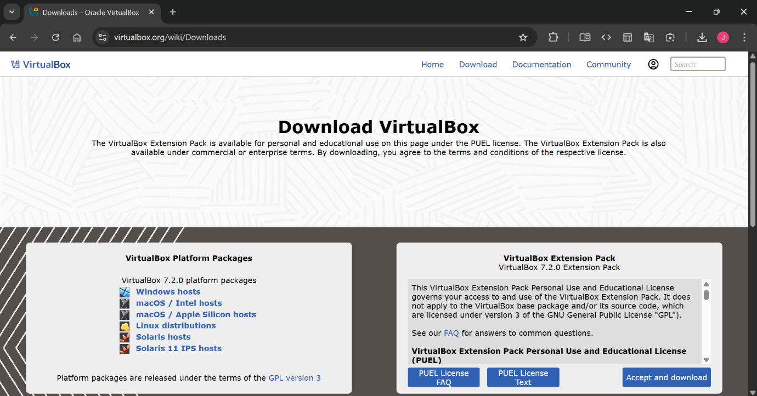

Screenshot 1: VirtualBox download page
Downloaded the Kali Linux 2025.2 VirtualBox Pre-Built Image (amd64) from Kali’s official page.
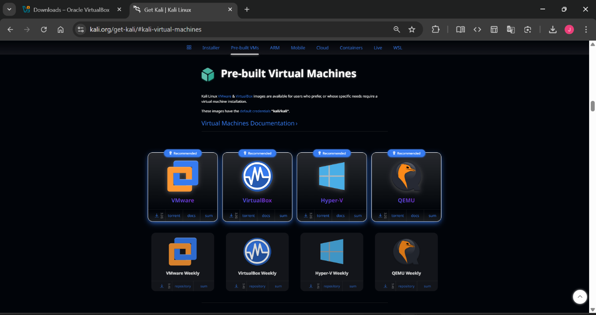

Screenshot 2: Kali Linux Pre-Built Image download page
Step 2: Setting Up VirtualBox
Installed VirtualBox on the host system (Windows 11).
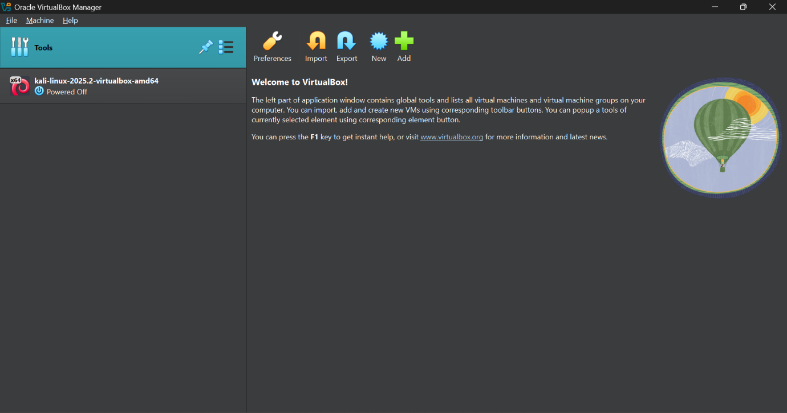

Screenshot 3: Oracle VirtualBox Home screen

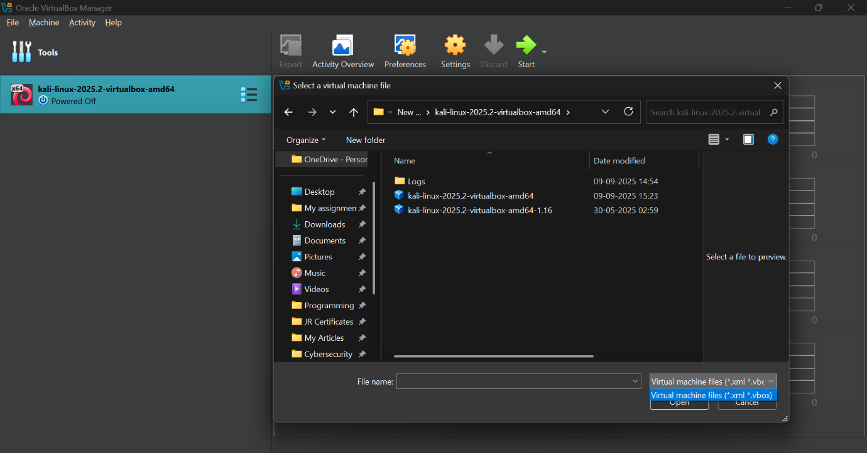
Imported the Kali Linux .ova/.vbox file into VirtualBox.

Screenshot 4: choosing Kali Linux .vbox pre-image file

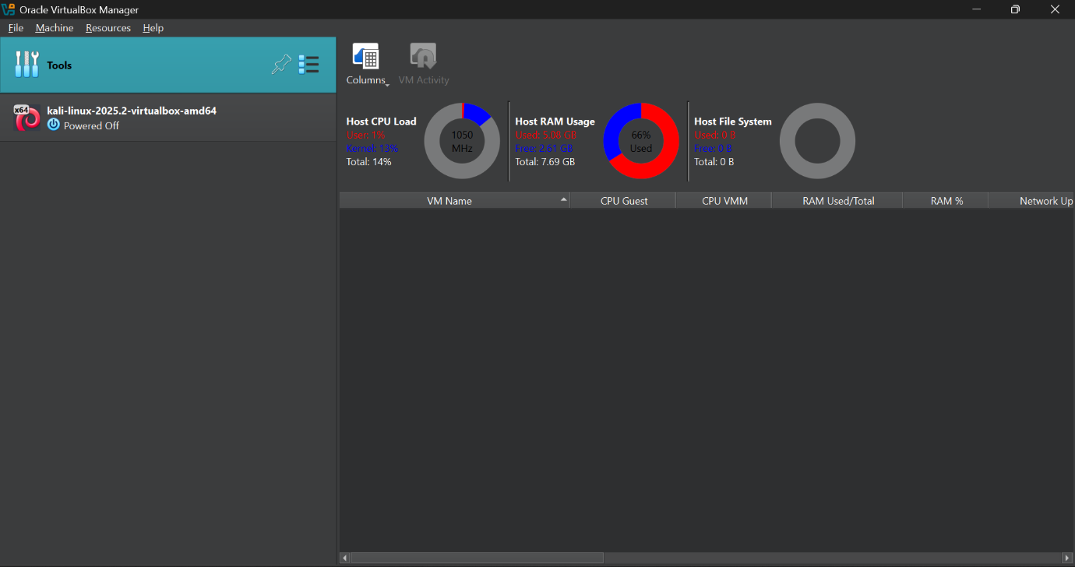

*Configured VM settings: 4 GB RAM, 2 CPU cores.
Screenshot 5: VM settings showing RAM/CPU allocation

Step 3: Running Kali Linux for the First Time
- Booted Kali Linux VM successfully.
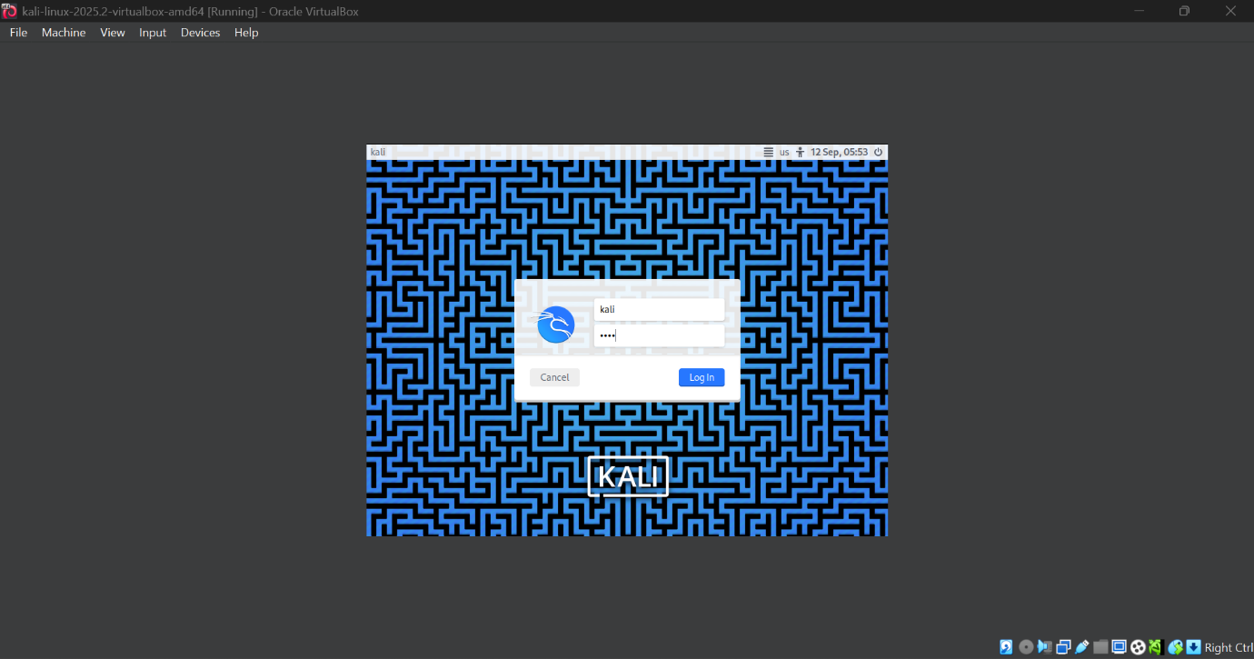

- Logged in using default credentials.
Screenshot 6 : Kali Linux login screen

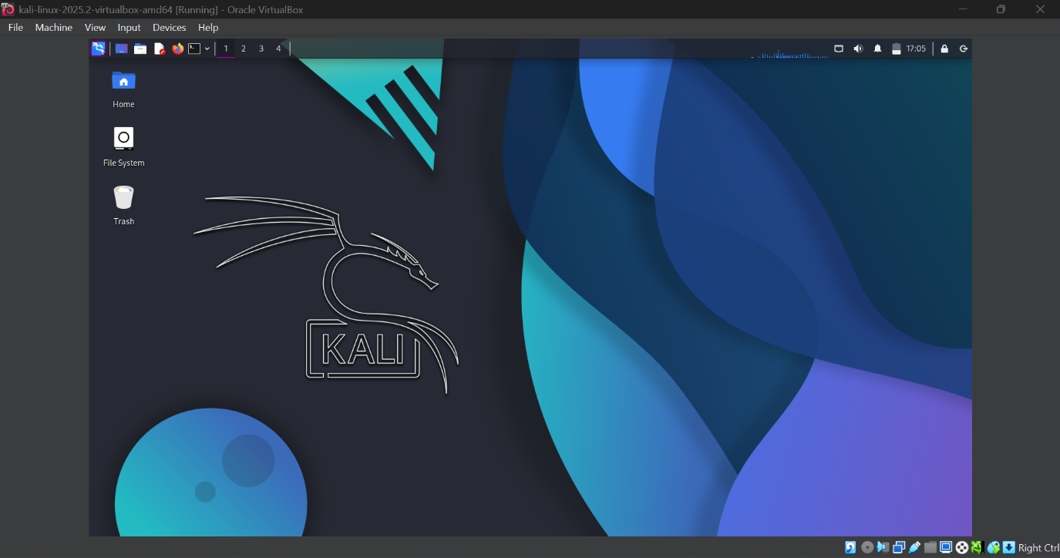

- Verified that desktop loaded properly.
Screenshot 7: Kali Linux desktop environment after login

Step 4: Basic Verification & Updates
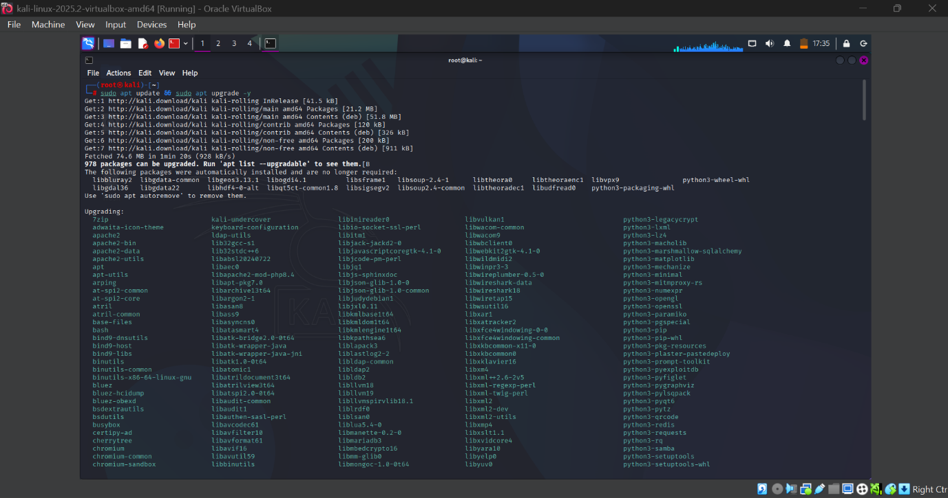

Ran initial update (sudo apt update && sudo apt upgrade -y).
Screenshot 8: Terminal showing update process

Verified tools are pre-installed such as the following.
- Nmap
- Wireshark
- Metaspoitable
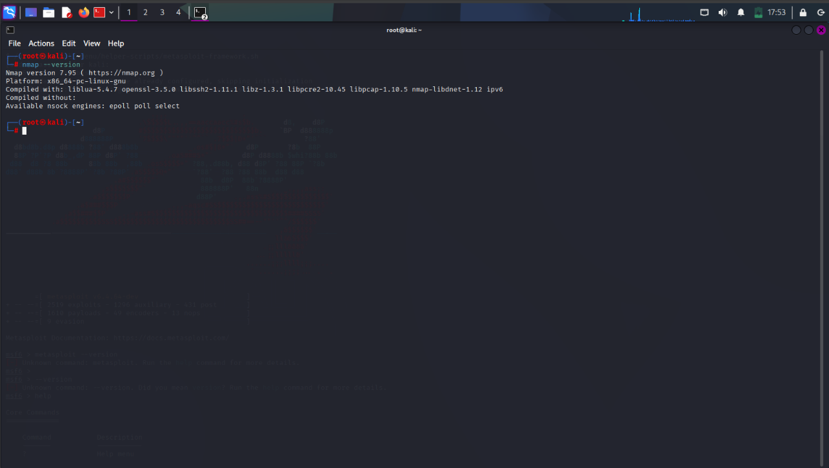

Nmap Version – 7.95 : It is an open network source tool for network exploration and security auditing, used to discover hosts, services, operating systems, and potential vulnerabilities on networks

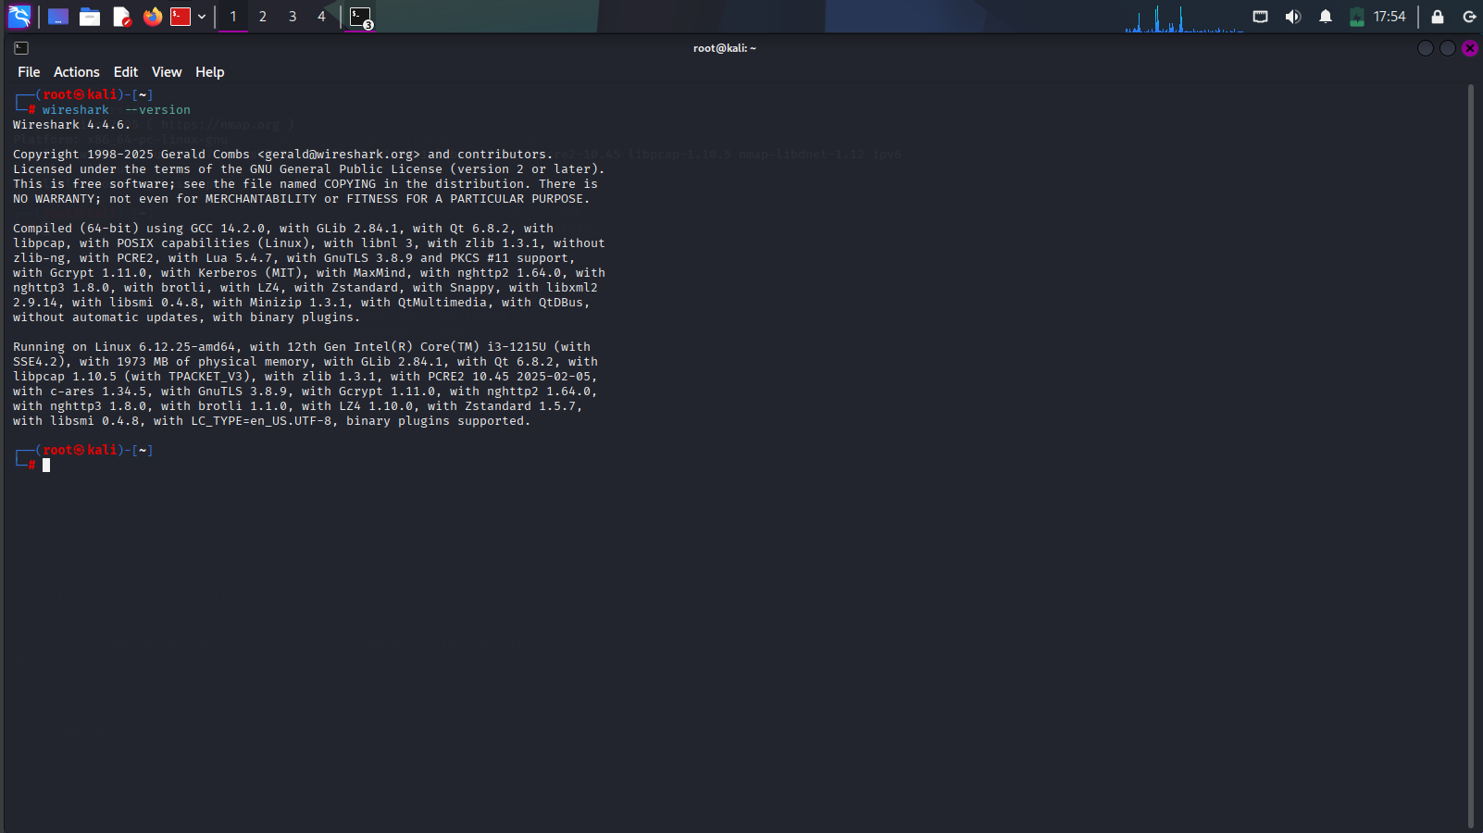

Wireshark Version – 4.4.6 : to capture, inspect, and analyze network traffic at the packet level to identify and resolve network issues, troubleshoot performance problems, detect security vulnerabilities, understand network protocols, and for education and software development

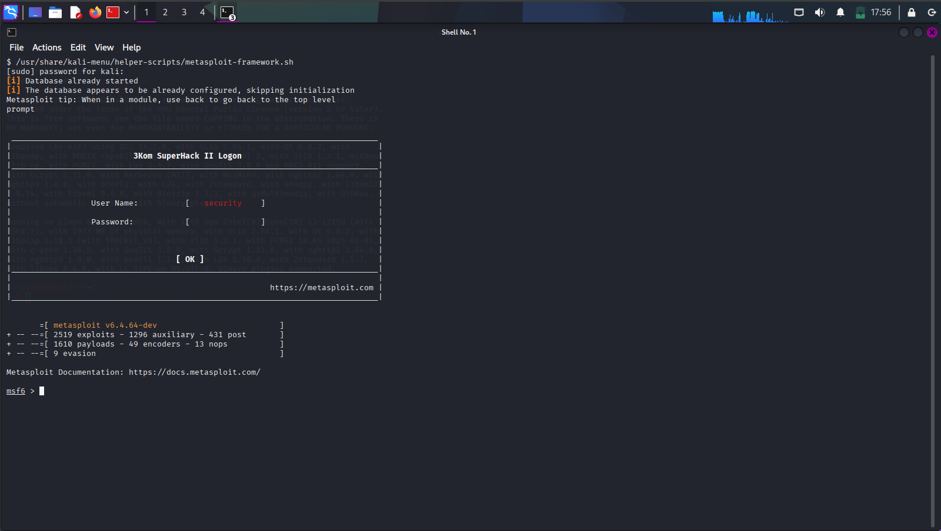

Metasploit Version – v6.6.64 : Metasploit's purpose is to act as a penetration testing framework, providing a collection of tools for identifying and exploiting security vulnerabilities, helping security professionals to test networks and systems, develop and execute exploit code, and ultimately improve system defence’s against attacks.

Screenshots 9, 10 & 11: Nmap, Wireshark & Metasploit version check.

Additional Screenshots of Commands
Net Tools: tcpdump
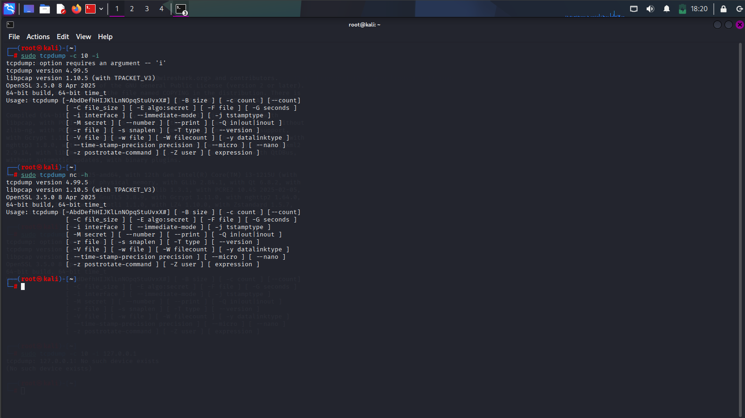

Screenshot 12: Nettools version check

The setup was completed successfully. The Virtual Machine is now ready for use in further penetration testing and security tasks.

